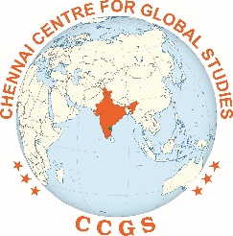



President

& Founder Trustee – R. Sadagopan Treasurer - S. Ashok

Vice President & Trustee – N.S. Ragunathan Genl Secretary - E. Dhandapani

Contact details –

3-E, I Block Ceebros Shyamala Gardens Contact - 9840030968 / 8056009575

No- 136 Arcot Road, Saligramam email - chennaicgs2014@gmail.com

Chennai – 600093

Contents

To sum up the major events 3

To mention programs that CCGS organized. 3

1. On 13-Dec-2014 - “Stronger Economy for Resurgent India” – a meet of business leaders and intellectuals with vast experience and expertise on global affairs 3

2. On 22-Nov-2015 – “Make in India” – a meet addressed by intellectuals who were in government service and other professional 4

3. 2015, June - Malayain Tamils-A overview in Hrawat Palace Mylapore. 4

4. 2017, January - AKHANDA TAMIL ULAGAM – 2ND CONFERENCE 4

5. 2017, March - Tamil Diaspora – Myth and Reality – 17.03.2017 @ New Woodlands Hotel, Dr Radhakrishnan Salai, Chennai 5

6. Interesting session on making India Globally Strong Challenges - Opportunities -Our Role on 23.07.2018 @ Quality Inn, Sabari, Chennai 5

7. 2018, September - TAMILS IN REUNION: LOSING CULTURAL IDENTITY 6

8. 2019, June - SOUTHEAST ASIA’S CULTURAL INDEBTEDNESS TO INDIA 7

Appendix 9

**Chennai Centre for Global Studies**

Chennai Centre for Global Studies (CCGS) is forum for public debate and evolution of public opinion on various issues that are of concern to the nation. A group of intellectuals located at Chennai commenced their initiative and mission way back in 2008 under the forum Indian Centre for South Asian Studies.

The high decibel political debate in recent times that preceded change in political leadership at the helm has created enormous expectations in the body polity. Bharath is once again at the proverbial crossroads of history. In the context of its trials and tribulations in the recent decades and of course with quite a good number of triumphs, it is cruising through challenging period indeed. In the eyes of comity of nations, India has arrived.

The current scenario features a multitude of factors -–

* A vibrant free enterprise that had been defying socialist model and proving its worth and whose expectations have earned political legitimacy; no one feels guilt tripped over making money and more and more of it.
* demographic dividend resulting from ever growing younger population reaching higher levels of literacy and exposure
* the imminent political cost of clinging to failed economic models, chiefly the risk of ever-growing unemployment of teeming population
* technological developments across the globe and the ease at which it dispersed through a vibrant globalized market and the acclaimed track record of India in imbibing these
* creation of global level institutions that are considered necessary for smooth transactions between nations.
* acute level of sensitivity towards deprivation of benefits to sections of the society and vibrant activism in fighting for remedy.

What is engaging the Intelligentia is an acute concern about how well prepared we are and how capable the present institutions are in meeting the challenges and achieving solutions. The point of convergence among different opinions is that India needs a better economy that would go a long way in fulfilling the wants of its younger population.

The Indians across the globe and the Tamil diaspora as a segment impacts and is impacted by the domestic developments. It is a relationship that reinforces mutually and achieves a grand synergy that has been demonstrated through the success of Indians at a pan global level.

It is against the above background that a group of intellectuals conceived the idea of creating a forum which will provide a meeting ground of thoughts, ideas, opinions and action plans between our citizens engaged in economic and other affairs in different walks of life.

Chennai Centre for Global Studies endeavors to reach out to the intelligentia and facilitate each and every interested person to contribute their best of efforts towards realizing the nation’s potential and leave a better India for next generation.

Citizens who are keen to be part of this movement are welcome to join us.

To sum up the major events, symposiums were organized as follows –

(1) 2008 on Deepening Political Crisis in Sri Lanka

(2) 2009 on Overseas Tamils Experience and Expectations

(3) 2010 on Emerging trends in Sri Lanka [I dont have any record of this]

(4) 2011 on action plan for global level Karyakarthas

(5) 2013 - Akanda Tamil Ulagam – 1 (AKHTU-1)

(6) 2014, December – Stronger Economy for Resurgent India

(7) 2015, June - Malayain Tamils-A overview

(8) 2015, November - Make in India - (A Meeting of the nationalist minded business leaders)

(9) 2017, January - AKHANDA TAMIL ULAGAM – 2ND CONFERENCE

(10) 2017, March - Tamil Diaspora – Myth and Reality

(11) 2018, July - Making India Globally Strong Challenges - Opportunities -Our Role

(12) 2018, September - TAMILS IN REUNION: LOSING CULTURAL IDENTITY

(13) 2018, December – 2 days Camp

(14) 2019, June - SOUTHEAST ASIA’S CULTURAL INDEBTEDNESS TO INDIA

Chennai Centre for Global Studies (CCGS) evolved into this new Avatar to pursue their objectives. CCGS is a trust registered (bearing No: 352/2016/BK4) whose founding trustees are two IT successful professionals namely, Shri.R. Sadagopan and Shri.N.S. Ragunathan.

CCGS takes its mission forward with a team of intellectuals dedicated to nationalism.

# To mention programs that CCGS organized.

# On 13-Dec-2014 - “Stronger Economy for Resurgent India” – a meet of business leaders and intellectuals with vast experience and expertise on global affairs

CCGS commenced its activities with the program of Business Leaders Meet on Saturday the 13th day of December 2014. The theme of the meet was “Global Presence of Resurgent India”.

Presidential address was delivered by Sri.N.S. Ragunathan a successful business leader and social activist.

The meet featured a panel discussion steered by the following eminent persons-

* Dr.S. Narayanan Former Economic Advisor to the PM, Former Secretary to Department of Revenue on the topic “India’s Economic Diplomacy”
* Sri.D.S. Rajan, Former Director, Cabinet Secretariat, New Delhi, Distinguished Fellow, Chennai Centre for China Studies on the topic “Sino Indian Relations, Challenges Ahead”.
* Prof. V. Suryanarayanan Former Member, National Security Advisory Board and former director Centre for South and South East Asian Studies on the topic “India’s Neighborhood Diplomacy”.

# On 22-Nov-2015 – “Make in India” – a meet addressed by intellectuals who were in government service and other professional

CCGS held a meet on the theme “Make in India” on 22nd November 2015. This meet was well attended and responded by participants who were from different fields. The program featured speeches by –

* on the topic “Make in India – New Initiatives” by Mr.M.R. Sivaraman former Union Revenue Secretary, former ED of IMF and Advisor to UN on countering terrorism.

He dwelt at length on the opportunities and challenges that India needs to handle to make this mission successful.

* On the topic “The Way Forward” by Shri. Arunkumar Davey, Founder of Mind Matters, Corporate consultant and Industrial Economist. He elaborated on the approaches and strategies that are needed for this mission.
* Special address was delivered by Shri.Ravikumar Coordinator of Sewa International to sum up the track record of success that Indians had achieved since time immemorial and how this is sustained as evidenced by the success stories of Indians in various fields across the globe. His address carried the message “We made it”.

# 2015, June - Malayain Tamils-A overview in Hrawat Palace Mylapore.

The program has started with Tamil Thai Vazhthu and Sri.Ashokji has given the Welcome address.

Our swayasevak Sri.Ganesh Parasuram has delivered the speech with Visual presentation. He has covered about Malaysian country history and our Tamil people’s past history and current situation. His presentation is well detailed and he covered economics, religious freedom, politics and social status. He highlighted about our Tamil people stateless conditions and economic situations

# 2017, January - AKHANDA TAMIL ULAGAM – 2ND CONFERENCE

CCGS held a meet of Tamils from across the globe representing the Diaspora. Titled as Akanda Tamil Ulagam – 2, (AKHU-2) at Golden Temple Sripuram (near Vellore) on 10th (Tuesday) and 11th (Wednesday) of January 2017.

120 delegates from 22 countries including 15 CCGS volunteers participated in the conference. The theme of the conference was the ancient Tamil universal adage “YADUM OORE YAVARUM KELIR” (to us all towns are one, all men our kin), which is Tamil equivalent of VASUDHAIVA KUTUMBAKAM, (World is one Family).

The conference started with delegates visiting the Golden Temple for a special puja on 9th Jan evening. The conference was inaugurated on 10th Jan morning after Gho Puja and prayers. Dr.G. Viswanathan Chancellor of Vellore Institute of Technology delivered the Key Note Address. Shakti Amma’s blessings were conveyed to the delegates by Shri. Suresh Babu, Director of Sripuram. Shri.Rajesh Sukul as representative of Maha Rajguru of Thailand, conveyed the blessings of Rajguru. Prof. Dr Vannia Rajan delivered the welcome message and Ravi Kumar explained the purpose of the conference.

Prof. Suryanarayan set the tone of the conference by giving an Overview of the Overseas Tamils. Shri. Su.Viswanathan, Shri. Sthanumalayan and Shri.Shyam Parande delivered special talks on Economic Principles in Thiru-Kural and Bhagwad Gita, Eternal Values for a dynamic society and Indian concept of Sewa. Dr. Shankar, Medical Director, Agarwal Eye Hospitals and Dr.Venkat Subbu of Darling Hotel Vellore & President, Tamilnadu Hotel Association also addressed the delegates

The meet featured a Special Lectures and Group discussion as followed.

Special Lectures

* Upholding Tamil Language and Culture La Ganesan
* Stateless People in Tamil Diaspora Prof Suryanarayanan
* Concept of Sewa in Indian Tradition Shyam Parande
* Eternal Values for Dynamic Society Ko Sthanumalayan
* Economic Concepts in Kural and Gita Su Viswanathan
* Need for Integration within Tamil Diaspora Dr. Ramasamy

Group discussion

* Nurturing Future Generations
* Problems faced by Indian Diaspora
* Economic conditions of Tamils in Diaspora
* Sewa activitis in Tamil Diaspora

Note 1: List of Countries participated – 22

Australia, Bharat, Ethiopia, Fiji, France, French Re-Union Islands, Hong Kong, Indonesia, Kenya, Kuwait, Malaysia, Mauritius, Myanmar, New Zealand, Oman, Singapore, South Africa, Sri Lanka, Tanzania, Thailand, UAE, USA,

Note 2: List of Sangha Adhikaris Attended - 12Sarvashri Prof Dr Vannia Rajan ji, Rajendran, Sthanumalayan, Sundar Lakshmanan, Samskrit Srinivasan, Shyam Parande, Sambamurthy, PM Ravi Kumar, Su Viswanathan, Vivekananthan (Prant Vidyarthi Pramukh), Gopi ji of Bharatiya Kisan Sangh and Rajasekhar Sewa Bharati.

# 2017, March - Tamil Diaspora – Myth and Reality – 17.03.2017 @ New Woodlands Hotel, Dr Radhakrishnan Salai, Chennai

Book release by

The book succinctly describes the challenges facing the Tamil Diaspora today. It focuses attention on the policies of the Government of India and the Government of Tamil Nadu towards them and what steps need to be taken so that the Tamil Diaspora could retain its Tamil identity, while at the same time, remain loyal citizens of the countries in which they live

# Making India Globally Strong Challenges - Opportunities -Our Role on 23.07.2018 @ Quality Inn, Sabari, Chennai

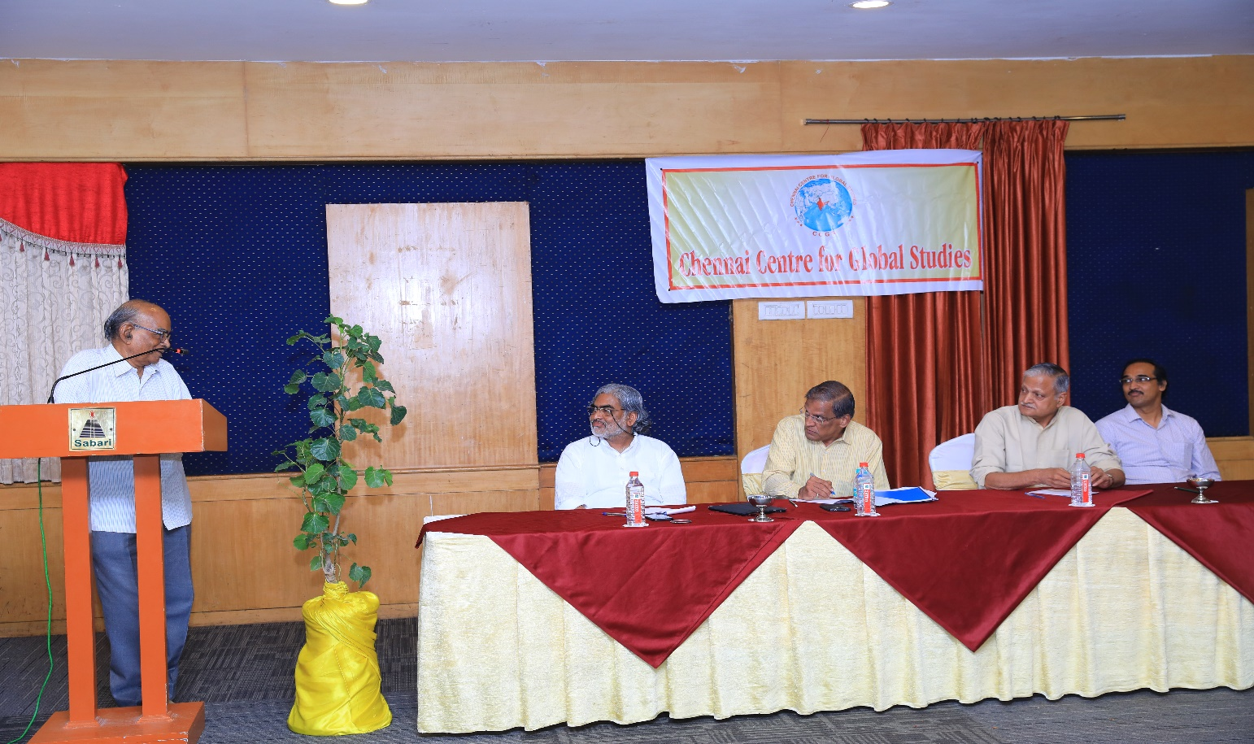

**Speakers:**

1. Shri. M.S. Sundar Rajan – Ex- Chairman, Indian Bank
2. Shri. Jeyakumar – Vigyan Bharathi (Intl. Science Forum)
3. Shri. Ravi Kumar – International Joint Co-ordinator, SEWA INTL.

The program commenced with the prayer by Shri. Ganpathy followed by the dance defining the patriotism.

The welcome address was presented by Shri. Dhandapani welcomed the dignitaries.

**Speech by the Dignitaries**

1. Shri Sadagopan

Briefed about the CCGS, In 2008 it was Indian center for south Asian Studies changed now globalized to Chennai Centre For Global Studies. Highlighted the constraint of Tamil People from Sri Lanka, Malaysian. Problems faced by China was discussed, conference named “Aganda Tamil Ulagam “held at Vellore. “Seva International” helps people of Srilanka for education.

1. Shri. Ravi Kumar

Spoke about Tamil Malaysians people at Jail and reason for poisoned. Highlighted Women Tamil Central Minister. Importance of Indian Youth, Education and Indian Students. Ratings of the Universities all over the World. Innovations done and introduced by Indians. Distinctions among the Countries. Indian peace keeping Pupils Empowerment of women and Children compared among other Countries. Foreigners joins the Indian Spirituals. Culture and Spiritual aspect.

1. Shri. M.S. Sundar Rajan

Enlightened Being Indian. Working population of Indians and envy of neighbors. Discussed on Average age in forthcoming Years, near future. Drawback of Engineers job Opportunity/seekers. Challenges faced by Indian Engineering Students. Banking / computer technology. Make in India, Skill development, and other technology developments. Changes introduced in NCERT and Tamilnadu state Syllabus. Challenges faced by Indian Unemployment. Enhancing student’s positivity and induction to Management possibility. Ended by saying “Knowledge is not to store but to share”.

1. Shri. Jeyakumar

Congratulated the crew of Chennai Centre of Global Studies for their initiatives. . Challenges faced while getting admission faced. Highlighted the overall aspect of challenge faced by the Indians.

# 2018, September - TAMILS IN REUNION: LOSING CULTURAL IDENTITY

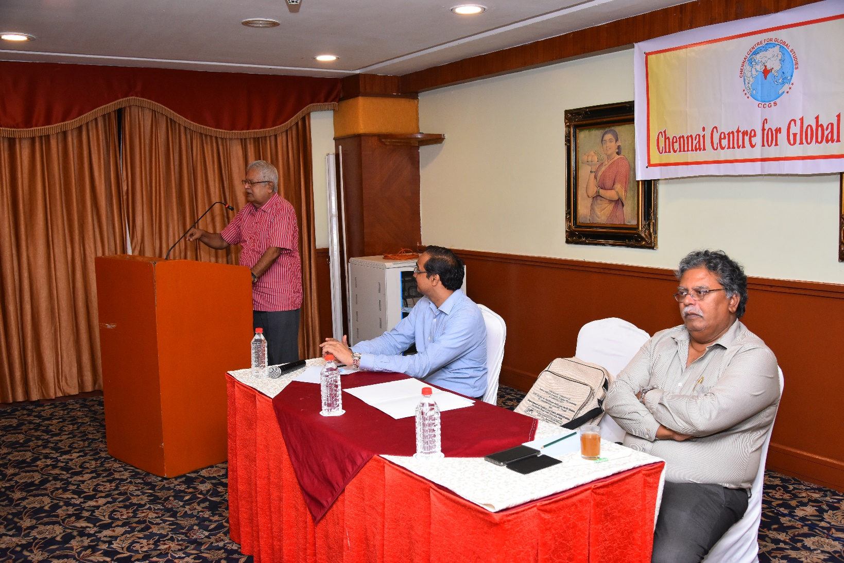

Dr. Kalai Selvam Shanmugam, President, Tamil Sangham, Reunion was in Chennai recently. The Chennai Centre for Global Studies arranged an informal get together with those involved in the study and research on Tamil Diaspora. In his candid and frank presentation, Dr. Shanmugam described the nature of their migration, the trials and tribulations they underwent and how, despite heavy odds, the Tamil community has made a mark in the social, economic and political life of the county. In order to understand their problems, it is necessary to highlight certain realities about Reunion.

Dr Shanmugam’s lucid presentation was followed by a lively discussion. On the specific question of different religious practices co-existing in Reunion, it was felt that any attempt to project one form of worship to be superior to another form will create divisions within the Tamil Society.

The audience felt deeply pained when Dr Shamugam pointed out that some *Gurukkals* (Temple priests) brought from Tamil Nadu were more interested in making money than in spreading the gospels of Hinduism. The Visva Hindu Parishad must immediately take corrective steps in this matter.

Dr. Shanmugam highlighted and contrasted the policy being pursued by China in strengthening Chinese identity among the miniscule Chinese population. China, which has good relations with France, has opened Confucian centers in Reunion; these Centers teach Chinese language to the local Chinese and also encourage their regular visits to China.

Dr. Shanmugam suggested that it will be a good idea if the Government of India provides facilities for the Tamils in Reunion to acquire Overseas Indian Citizenship. Dr. Shanmugam has acquired Overseas Citizenship of India (OCI) cards. It was easy for him because he migrated to Reunion after independence; he had also the necessary documentation about date and place of birth etc.

# 2019, June - SOUTHEAST ASIA’S CULTURAL INDEBTEDNESS TO INDIA

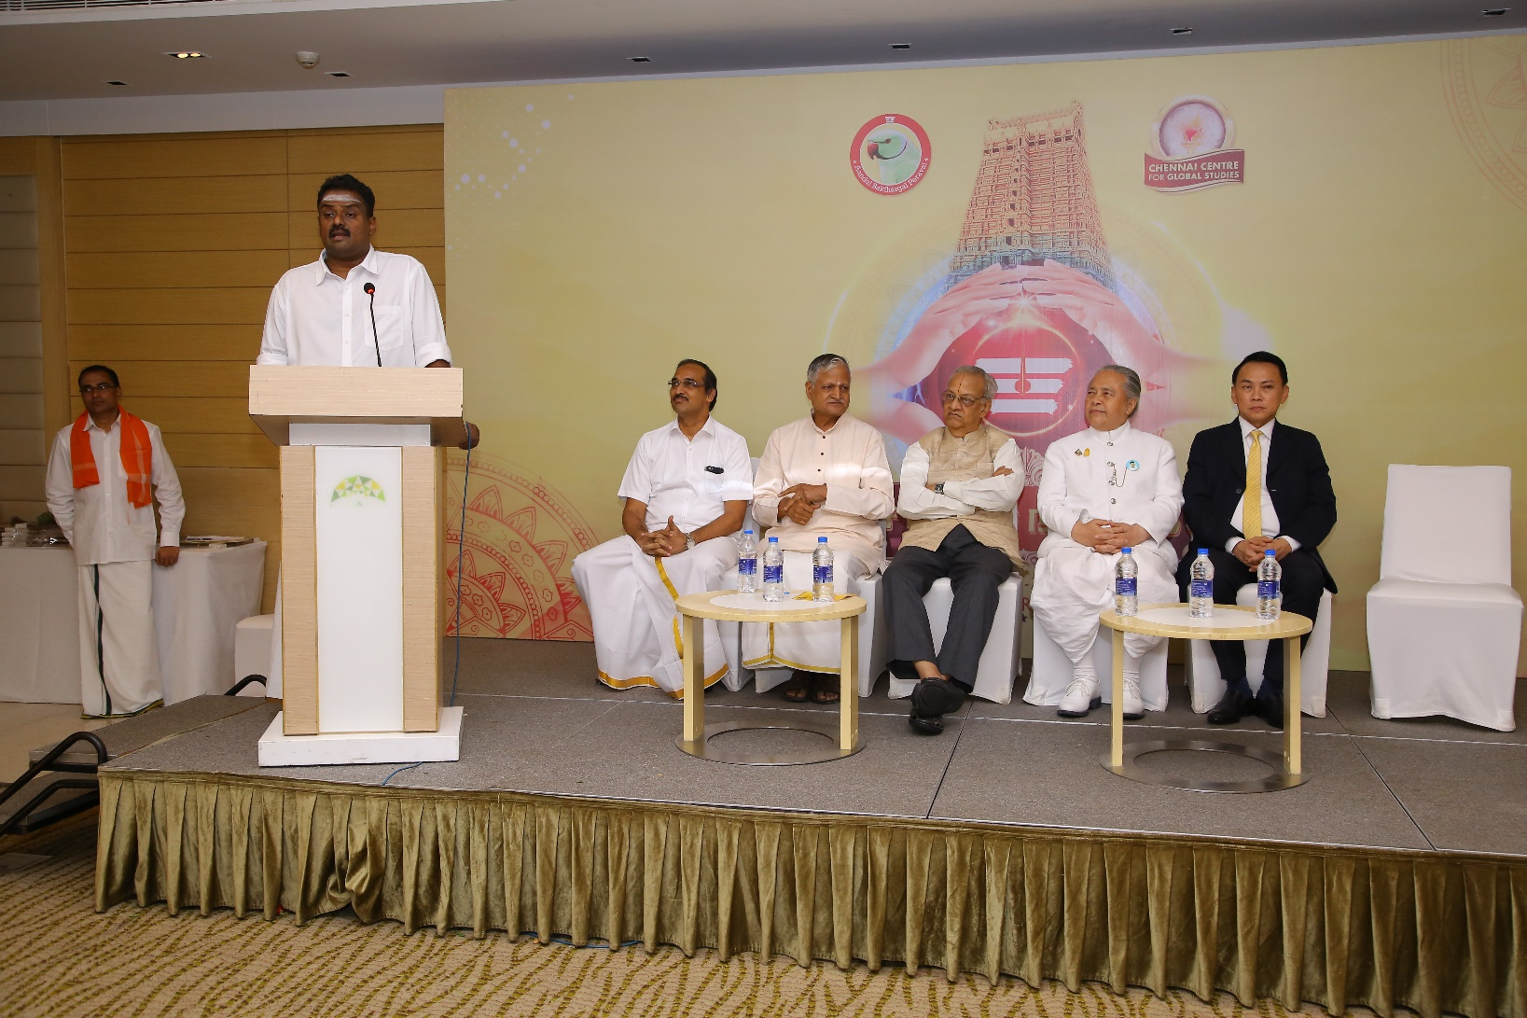

On June 25, 2019 Chennai witnessed a spectacular and memorable meeting. The meeting was organized by *Andal Bakthargal Peravai* and Chennai Centre for Global Studies. The Guest of Honour was *Phra Maha Raja Guru Bidhsrivisudhigun, t*he religious adviser and preceptor to the King of Thailand. The Rajguru performs the religious rites associated with coronation as a result of which the King acquires divinity and gets the title of Rama. The entourage of Rajguru consisted of four people, and they were dressed in white dhoti worn up to the knees, a white buttoned up coat and white shoes. What was striking about the entourage was their well- oiled *kudumi* (tuft) which proves that their ancestors hailed from Tamil Nadu. There are 14 Brahmins today in Thailand, they are highly respected and they keep alive the Hindu traditions. In fact, they are unofficial Indian ambassadors in Thailand.

# 2019, July – Veera Mangai Velu Nachiyar – un comparable and unique leader of her time

# 

# Appendix

2014, December – Stronger Economy for Resurgent India



2015, June - Malayain Tamils-A overview



2015, November - Make in India - (A Meeting of the nationalist minded business leaders)



2017, January - AKHANDA TAMIL ULAGAM – 2ND CONFERENCE



2017, March - Tamil Diaspora – Myth and Reality



2018, July - Making India Globally Strong Challenges - Opportunities -Our Role



2018, September - TAMILS IN REUNION: LOSING CULTURAL IDENTITY



2019, June - SOUTHEAST ASIA’S CULTURAL INDEBTEDNESS TO INDIA



2019, July – Veera Mangai Velu Nachiyar – un comparable and unique leader of her time

